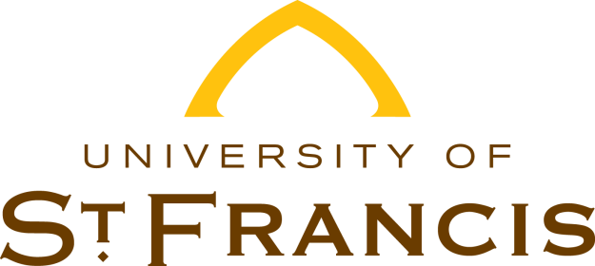

**VERIFICATION OF CITIZENSHIP STATUS**

**2025-2026**

Financial Aid Services recently reviewed your Student Aid Report for the 2025-2026 academic year. The Social Security Administration did not confirm that you are a U.S. Citizen.

One of the following items is needed to prove citizenship. Please present the original documentation to a staff member in our office.

* Certificate of Naturalization (N-550 or N-570)
* Certificate of Citizenship (N-560 or N-561)
* U.S. student’s birth certificate
* U.S. passport (current or expired) - limited passport is NOT acceptable
* Wallet-sized passport card (current or expired)
* Certification of foreign birth (FS-240, FS0545 or DS-1350)

If you are not able to present the original document to our office, please submit a legible copy to our office via e-mail or regular mail.

Failure to submit eligible documentation will prevent you from receiving any Federal or State financial assistance. Please contact our office at (815)740-3403 or toll free at (866)890-8331 if you have any questions regarding this letter.

Sincerely,

Financial Aid Services

Please submit your documentation to:

**Financial Aid Services**

500 Wilcox Street Joliet, IL 60435 | finaid@stfrancis.edu

(815) 740-3403 | Toll-free: (866) 890-8331 | Fax: (815) 740-3822